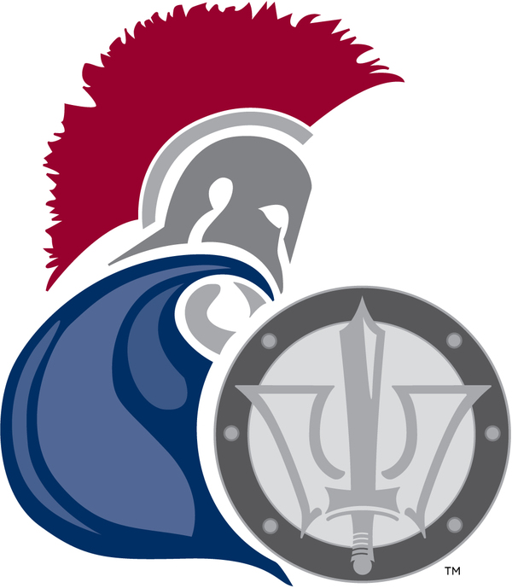

November 9, 2014

Dear Friends of Education,

Moores Mill Intermediate School is a brand new school in our community is serving students in grades four through six. The faculty and staff are excited to continue working with these students in the 2014- 2015 school year. The new building is a fabulous addition to our community! In order to enhance our campus further, we are working diligently to install a playground for the children. Recess is such an important aspect of learning that not only gives the students a break to recharge their minds, but also allows them the necessary time to strengthen their bodies. We need your help to build our playground.

Our goal is 100% community support with this project. We are asking businesses to help make an annual 5K run a success. There are many ways to help and we are requesting that you fill out the 5K-support sheet. Will you please find one or more ways to aid us in this project?

All businesses that make a significant monetary or item donation will receive recognition on race day. These businesses will also be advertised on the back of the shirts that will be given to race participants. In preparation for the race, we will be distributing fliers. The businesses that donate early enough will be included in the fliers and brochures as well.

We greatly appreciate your time and consideration in assisting us as we work to raise the necessary funds to build our playground. Your help will strengthen our students and our community. Please join us at our race event on Saturday, August 29, 2015, at 7:00 am.

Sincerely,

Jennifer Sticker
MMIS 6th Grade Teacher/Race Director

